Bahria University,

Karachi Campus



LAB EXPERIMENT NO.

**5**

LIST OF TASKS

|  |  |
| --- | --- |
| TASK NO | OBJECTIVE |
| 1 | While utilizing the Linux commands studied so far, provide an example of a combination of several Linux commands in which pipes are used more than once. Also provide a snapshot of the generated output. |
| 2 | Write C program to print all alphabets from a to z using while loop (Using ASCII). |
| 3 | Write a shell script that records the full path of all the files present within a directory into a record.txt file. Along with full path name, the script should also record the number of words, characters and lines within each file. |
| 4 | Write a C program that asks the user to provide an integer input in the *main()* function. The program would call a function *even_odd()* from the *main()* function, where the function *even_odd()* accepts an integer as an argument, determine and display if the passed integer is either even or odd. |
|  |  |

Submitted On:

Date: 11/04/2022

**Task 1: While utilizing the Linux commands studied so far, provide an example *(other than the one shown in this Lab)* of a combination of several Linux commands in which pipes are used more than once. Also provide a snapshot of the generated output.**

**SOLUTION :**

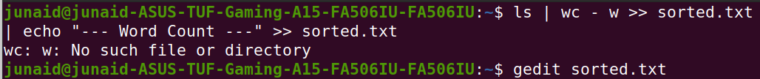

**OUTPUT :**

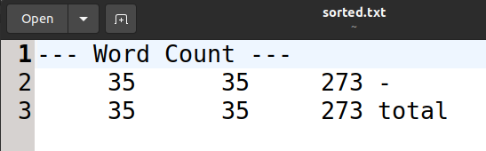

**Task 2: Write C program to print all alphabets from a to z using while loop (Using ASCII).**

**SOLUTION :**

#include<stdio.h>

void main(){

for(int i = 65;i<=95;i++){

printf("%c",i);

}

}

**OUTPUT :**

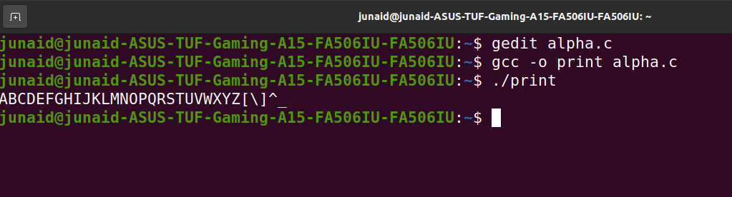

**Task 3: Write a shell script that records the full path of all the files present within a directory into a record.txt file. Along with full path name, the script should also record the number of words, characters and lines within each file.**

**SOLUTION :**

#!/bin/bash

echo "All the Files: " > record.txt

readlink -f lab3/* >> record.txt

echo "Word Count in each file: " >> record.txt

wc -w lab3/* >> record.txt

echo "Characters in each file : " >> record.txt

wc -m lab3/* >> record.txt

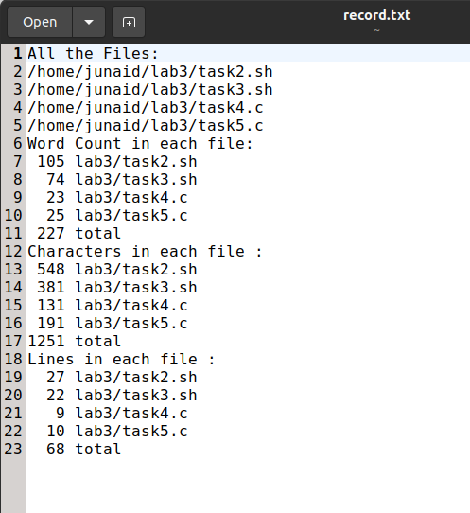echo "Lines in each file : " >> record.txt

wc -l lab3/* >> record.txt

**OUTPUT :**

**Task 4 : Write a C program that asks the user to provide an integer input in the *main()* function. The program would call a function *even_odd()* from the *main()* function, where the function *even_odd()* accepts an integer as an argument, determine and display if the passed integer is either even or odd.**

**Solution :**

#include <stdio.h>

void even_odd(int n);

void main(){

int in;

printf("Enter any number = ");

scanf("%d",&in);

even_odd(in);

}

void even_odd(int n){

if(n%2 == 0){

printf("Number is even.\n"); }

else

printf("Number is odd.\n");

}

**OUTPUT :**

